**2.15 Automate the Web Application**

DESCRIPTION

**Project objective:**

Use the website link given to you and automate different functionalities for the same. Create a new project and include all the dependencies in the class path. Create a Java class that will contain your automation and test scripts. Run the project using TestNG.

**Output of Console**

[RemoteTestNG] detected TestNG version 7.4.0

SLF4J: Failed to load class "org.slf4j.impl.StaticLoggerBinder".

SLF4J: Defaulting to no-operation (NOP) logger implementation

SLF4J: See http://www.slf4j.org/codes.html#StaticLoggerBinder for further details.

Starting ChromeDriver 106.0.5249.61 (511755355844955cd3e264779baf0dd38212a4d0-refs/branch-heads/5249@{#569}) on port 53272

Only local connections are allowed.

Please see https://chromedriver.chromium.org/security-considerations for suggestions on keeping ChromeDriver safe.

ChromeDriver was started successfully.

Oct 17, 2022 10:54:26 AM org.openqa.selenium.remote.ProtocolHandshake createSession

INFO: Detected upstream dialect: W3C

Oct 17, 2022 10:54:26 AM org.openqa.selenium.devtools.CdpVersionFinder findNearestMatch

INFO: Found exact CDP implementation for version 106

If the Logo matches, prints as true else false: true

Starting ChromeDriver 106.0.5249.61 (511755355844955cd3e264779baf0dd38212a4d0-refs/branch-heads/5249@{#569}) on port 57509

Only local connections are allowed.

Please see https://chromedriver.chromium.org/security-considerations for suggestions on keeping ChromeDriver safe.

ChromeDriver was started successfully.

Oct 17, 2022 10:54:33 AM org.openqa.selenium.remote.ProtocolHandshake createSession

INFO: Detected upstream dialect: W3C

Oct 17, 2022 10:54:33 AM org.openqa.selenium.devtools.CdpVersionFinder findNearestMatch

INFO: Found exact CDP implementation for version 106

Driver title: Authentication required

Registration successfully

Starting ChromeDriver 106.0.5249.61 (511755355844955cd3e264779baf0dd38212a4d0-refs/branch-heads/5249@{#569}) on port 50692

Only local connections are allowed.

Please see https://chromedriver.chromium.org/security-considerations for suggestions on keeping ChromeDriver safe.

ChromeDriver was started successfully.

Oct 17, 2022 10:54:56 AM org.openqa.selenium.remote.ProtocolHandshake createSession

INFO: Detected upstream dialect: W3C

Oct 17, 2022 10:54:56 AM org.openqa.selenium.devtools.CdpVersionFinder findNearestMatch

INFO: Found exact CDP implementation for version 106

The titles does not match with each other

Starting ChromeDriver 106.0.5249.61 (511755355844955cd3e264779baf0dd38212a4d0-refs/branch-heads/5249@{#569}) on port 63161

Only local connections are allowed.

Please see https://chromedriver.chromium.org/security-considerations for suggestions on keeping ChromeDriver safe.

ChromeDriver was started successfully.

Oct 17, 2022 10:55:02 AM org.openqa.selenium.remote.ProtocolHandshake createSession

INFO: Detected upstream dialect: W3C

Oct 17, 2022 10:55:02 AM org.openqa.selenium.devtools.CdpVersionFinder findNearestMatch

INFO: Found exact CDP implementation for version 106

Driver title: Amazon Sign In

Login successfully

Starting ChromeDriver 106.0.5249.61 (511755355844955cd3e264779baf0dd38212a4d0-refs/branch-heads/5249@{#569}) on port 52008

Only local connections are allowed.

Please see https://chromedriver.chromium.org/security-considerations for suggestions on keeping ChromeDriver safe.

ChromeDriver was started successfully.

Oct 17, 2022 10:55:20 AM org.openqa.selenium.remote.ProtocolHandshake createSession

INFO: Detected upstream dialect: W3C

Oct 17, 2022 10:55:20 AM org.openqa.selenium.devtools.CdpVersionFinder findNearestMatch

INFO: Found exact CDP implementation for version 106

Driver is exited, process execution is successful

===============================================

Suite

Total tests run: 5, Passes: 5, Failures: 0, Skips: 0

===============================================

**Screenshots**

Start of Chrome WebDriver

Automation process began

Output of matching the logo, flag returns true as match is found with defined condition

Automation of Amazon’s Registration Page, all the data are filled as per the instructions provided

Results display of Logo matching and Registration in the console

Automation process of Amazon’s Signin Page

The username or email is validated, so the page gets redirected to the Password authentication

Running of Amazon website to check the Title match of the Website

The title did not get matched, so the result is displayed for the same

Running the Add to cart menu of Amazon page

Samsung Galaxy S series is given as an input to test the various functionalities

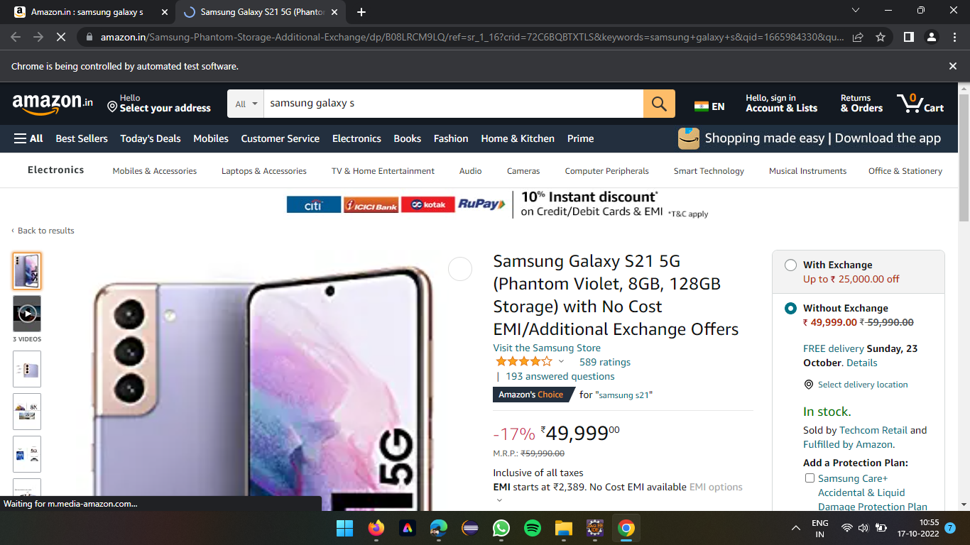

A web page of Samsung Galxy S21 5G is displayed after the search based linktext added

Result of console after all the tests run and completed successfully

Results of running suite after all the tests completion

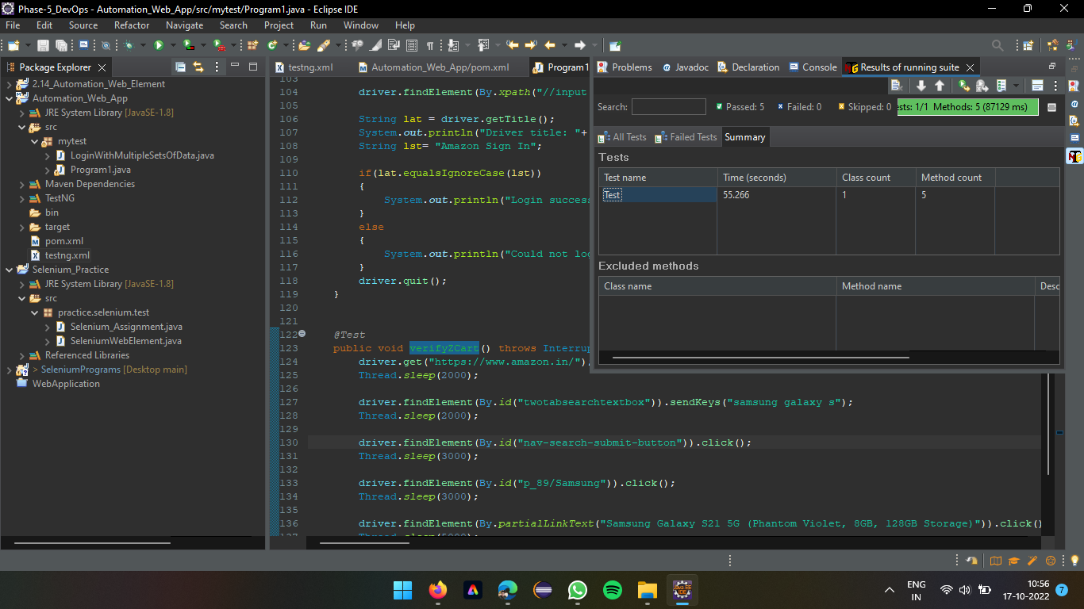

Summary of complete Test, time taken, number of methods